Year 5 Home Learning Menu - Autumn  Choose at least three of these fun activities to complete.  Bring your completed work into school to share with the rest of the class by Friday 12th December 2025.  Weekly Home learning Tasks:  Reading – Read for 20 minutes each day.  Spelling – learn your weekly spellings list for a dictation on a Friday.  Maths - Each week complete your Mathletics tasks. | Art  - Sketch some ideas for a sculpture or installation.  - Research installation artists and some of their work.  - Create your own piece of installation work.  - Show how everyday items can be used for a sculpture.  DT  - Find 3 real-life examples of gears and explain their functions.  - Create a poster on how pulley systems are used and their purpose.  - Research eco-bikes and explain how they help the environment. | English  - Create and present your own monster, including a model.  - Present a news report of a sighting of a monster.  - Write an account of an encounter with a monster.  - Present and perform your own cinquian on any topic..  - Write your own adventure story – prose or graphic novel.  - Write a biography of a character in history.  - Write a biography of a character that you have created.  - Prepare a slide show about a character – real or fictional.  - Imagine an encounter with your hero. | Science  - Investigate properties of different materials.  - Explain why items you find around your home are made from certain materials e.g pans are made from metal because they conduct heat.  - Explore irreversible and reversible changes – e.g. bake something and explain what changes have happened.
Maths  - Use the link for the Top Marks to practice arithmetic skills https://www.topmarks.co.uk/Search.aspx?Subject=16&AgeGroup=3  Purple Mash 2Dos  Practise multiplication tables  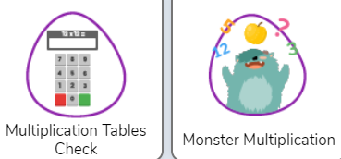 | History  How have children’s lives changed?  - Interview a parent or grandparent about their childhood.  - Choose a period in the past (Victorians, Tudors etc) and explore the lives of children in those times.  - Explore how a particular area of children’s lives has changed over time (e.g toys, clothes, schools, work). | Geography  Why do oceans matter?  - Find out about the different oceans and create a fact file  - Research an animal that lives in the ocean  - Outline all the ways the oceans help the planet  - Research all the ways the oceans and their creatures are being damaged. | 